**How to Set Up a Windows Login Banner (Legal Notice)**

A **Windows login banner** is a message that appears before a user logs into the system. Organizations often use it to display legal disclaimers, security notices, or acceptable use policies. This guide walks you through setting up a login banner using the Windows Registry or Group Policy Editor.

**Step 1: Open Security Policy Editor**

1. Press Windows + R to open the **Run** dialog.
2. Type secpol.msc and hit **Enter**.

Windows XP

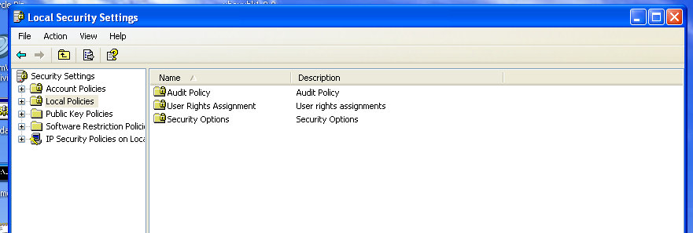

**Step 2: Navigate to the Policy Path**

Go to:

Computer Configuration > Windows Settings > Security Settings > Local Policies > Security Options

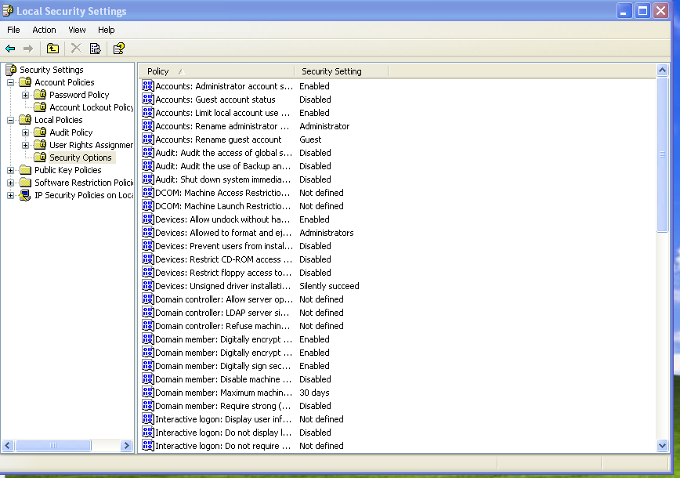

**Step 3: Set the Banner Title and Text**

1. Double-click on **Interactive logon: Message title for users attempting to log on**
   * Enter your desired **banner title** (e.g., "BMN 1234 Security Notice"). Change the BMN number to the correct value.
2. Double-click on **Interactive logon: Message text for users attempting to log on**
   * Enter the **full message** you want users to see (e.g., a legal disclaimer or company policy).

**Banner title:**

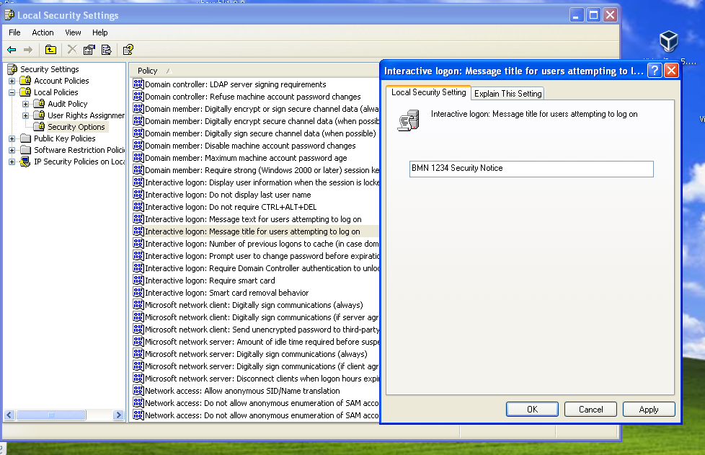

**Banner Message Example Message (for Compliance)**

**Text:**  
"This system is for authorized users only. All activities on this system are monitored and recorded. By logging in, you acknowledge and consent to such monitoring. Unauthorized access is prohibited and may be subject to criminal prosecution."

Put all the text on a single line. Windows formats this in to the correct space automatically.

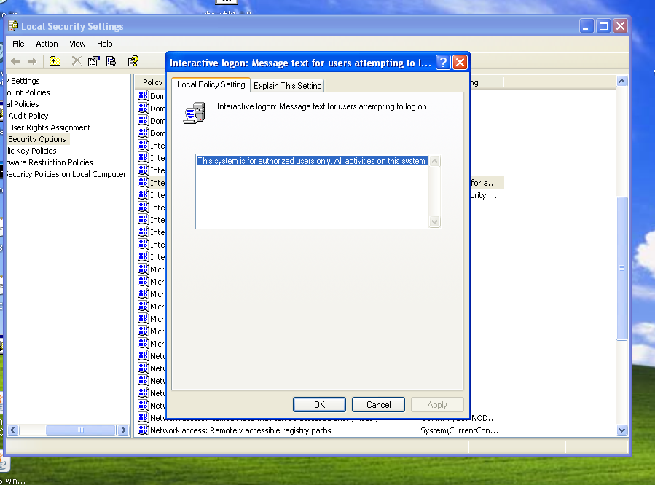

**Step 4: Apply and Exit**

Click **Apply** > **OK**, then close Group Policy Editor. The banner will appear the next time someone tries to log in.

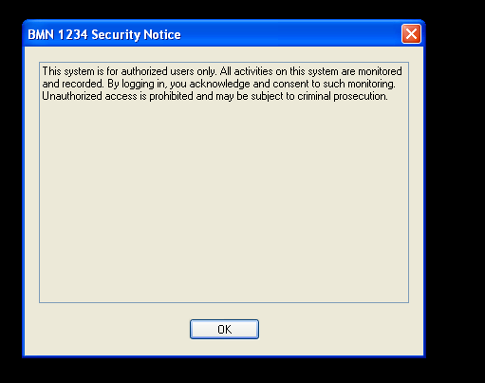

Windows 10\11 view of the same message

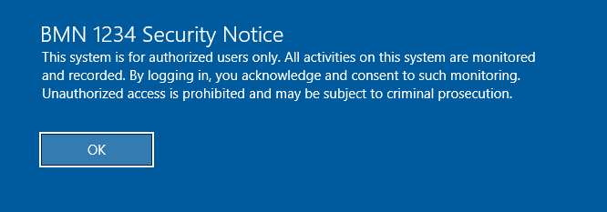

**Why Use a Login Banner?**

* Comply with **security policies** and regulations (e.g., Industry Security Notice
* Number 2024/09 (Issued 19/08/2024) Security Aspects Letters and Contractual Security Conditions item 26 ref H).
* Provide **legal protection** in the case of unauthorized access.
* Inform users about **acceptable use policies** and monitoring.

**Tips and Best Practices**

* Keep your message **clear and concise**.
* Avoid overly technical jargon.
* Review your message with **legal or compliance teams** if needed.

# Set the login banner title and message using the registry

# Define banner title and message

$bannerTitle = "Notice to All Users"

$bannerMessage = @"

This system is for authorized users only. All activities on this system are monitored and recorded.

By logging in, you acknowledge and consent to such monitoring.

Unauthorized access is prohibited and may be subject to criminal prosecution.

"@

# Registry path for login banner

$regPath = "HKLM:\SOFTWARE\Microsoft\Windows\CurrentVersion\Policies\System"

# Set the registry values

Set-ItemProperty -Path $regPath -Name "legalnoticecaption" -Value $bannerTitle

Set-ItemProperty -Path $regPath -Name "legalnoticetext" -Value $bannerMessage

# Output result

Write-Host "Login banner has been successfully set." -ForegroundColor Green

Set-ExecutionPolicy -Scope Process -ExecutionPolicy Bypass -Force

